ONE FORM PER DOG PER DAY
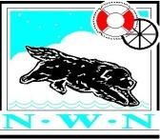

Northern Working Newfoundlands - Water Test Entry Form
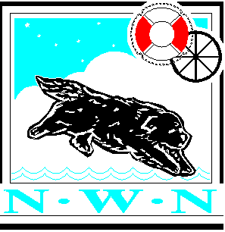
With: Rother Valley Training Group

Venue: Rother Valley (SECTIONS C & D ONLY) Date: MONDAY AUG 29th 2022

Please complete in BLACK INK & BLOCK CAPITALS Owner(s) Details
Name(s) | …………………………………………………………………………………………………….
Address | …………………………………………………………………………………………………….

…………………………………………… Postcode …………………………………………..

Contact No …………………………………………... Email ……………………………………………….

Handler Details (if different from above) ………………………………………………………….......................

If applicable - age of Junior Handler (10 yrs, up to & including 18 yrs) …………………….......................

NNC Membership Number ……………………………………….

To enter any tests the dog must be at least 6 months old on the day of the test for Section A, 9 months for Section B, 18 months for Section C & Section D & E is 24 Months. No entries will be accepted without entry fees. Please complete details below carefully - they will be used when filling out any pass certificates issued and the Test Records
Call Name | Registered Name | Date of Birth | Sex | Colour | Test Entered | Junior  Handler  (tick if  applicable)
All dogs MUST have obtained a pass at each Section, commencing at Section A, before entry is permitted to the next Section. Only exception for dogs who pass Section A for the first time may enter for Section B on the day, if the judges put them forward as capable and subject to dogs age and available time - see Regulations. All passes obtained at events organised by the Northern Newfoundland Club will be honored for NC & SNC members.

NNC Members - £8.00 NC/SNC Members - £10.50 (including NNC membership pending)
First Entry: ______ Total: __________ First Entry: ______ Total: __________
Subsequent test entries: ______ Total: __________ Subsequent test entries: ______ Total: __________
(£4.00) Total: __________ (£4.00) Total: __________

Payment options:
- Online Banking: Sort Code 30-97-51, Account Number: 04526427, Payment Ref: your name
– please attach proof of transaction to the Test Manager with entry form.
- Please make all cheques payable to Rother Valley Training Group
Please note that the Online payment has changed. Payment now goes to the host working group.

I / We undertake to abide by the rules and regulations of these tests and declare that the dog(s) entered have not contracted or been knowingly exposed to any infectious disease during the previous 6 weeks and are fit and healthy to undertake the tests entered. Furthermore I/we accept that any breach of the test rules or regulations may result in disqualification.
Signature of owner(s) …………………………………….. Date ………………………...................

Entry forms and cheques to be sent to the Test Manager. See schedule for details. If you require an acknowledgement of this entry please enclose a SAE.
Result | Pass or Fail (delete as appropriate)
Junior Points Gained
Payment Received | Online Payment / Cheque / Cash (delete as appropriate)

For Test Manager Use Only Please send a copy of this form with the test results marked to the Club's Record Keeper NNC Water Entry Form – AUG 22

